Page 1:
Present Details | To be modified
Advancing Global Knowledge and | Assign White Color
Welcome to RaxPublications | Give Space for Rax Publications
Welcome to Raxpublications, a premier digital publishing platform connecting researchers, scholars, and industry leaders through high-impact research. | Welcome to <strong>Raxpublications</strong> — a dynamic global publishing platform dedicated to advancing innovation, academic excellence, and impactful research. We bring together researchers, scholars, academicians, and industry professionals to share groundbreaking ideas, publish high-quality research, and inspire knowledge across diverse disciplines.  At Rax publications, we are committed to promoting excellence in scholarly communication through peer-reviewed journals, innovative research publications, and a seamless digital publishing experience. Our mission is to empower the global research community by providing a trusted platform for collaboration, discovery, and academic growth.  <strong>Explore. Publish. Inspire.</strong>  Join us in shaping the future of research and knowledge dissemination.
RaxPublications is a global platform dedicated to the dissemination of revolutionary research and technical news. Our mission is to provide an accessible and high-authority environment for researchers across Science, Engineering, and the Humanities.  We maintain a rigorous peer-review process to ensure that all published manuscripts meet the highest standards of academic integrity and innovation. Whether you are a student, a career researcher, or a technical professional, RaxPublications offers the resources you need to stay at the forefront of your field. | Rax Publications is an internationally recognized publishing platform committed to advancing knowledge through the publication of innovative research, emerging technologies, and impactful scholarly contributions. We provide a dynamic and trusted space for researchers, academicians, industry experts, and students to share ground breaking ideas across Science, Engineering, Technology, Management, and the Humanities.  Driven by excellence and academic integrity, we follow a rigorous peer-review process that ensures every manuscript meets the highest standards of quality, originality, and research ethics. Our mission is to bridge the gap between research and real-world innovation by making high-quality scholarly content accessible to a global audience.  At Rax Publications, we empower the research community with a platform that promotes collaboration, visibility, and scientific advancement. Whether you are an aspiring scholar, an experienced researcher, or a technical professional, our journals and publications help you stay connected with the latest developments shaping the future of research and innovation.
Privacy Policy | Remove
Terms of Service | Remove
GOOGLE SCHOLAR  DOAJ  CROSSREF  INDEX COPERNICUS | Remove
Contact Us  Address: 42 Tenkasi Road, Rajapalayam, Tamil Nadu 626117, India  Email: support@raxpublications.com  Phone: +91 1234567890 | Rax Publications  (Shanmuga Digital Premises)  5 , Jakkier Hussain Street ,  Opposite to Throwpathi Amman Kovil Arch, Sankarankovil - 627756 , Tamilnadu , India.  Mail : editor.ijcst@raxresearch.com  Mobile: 0091 – 8248610227

2nd Tab : Journals
International Journal of Data Science and AI (IJDSAI) | Remove all details
After click Journal | 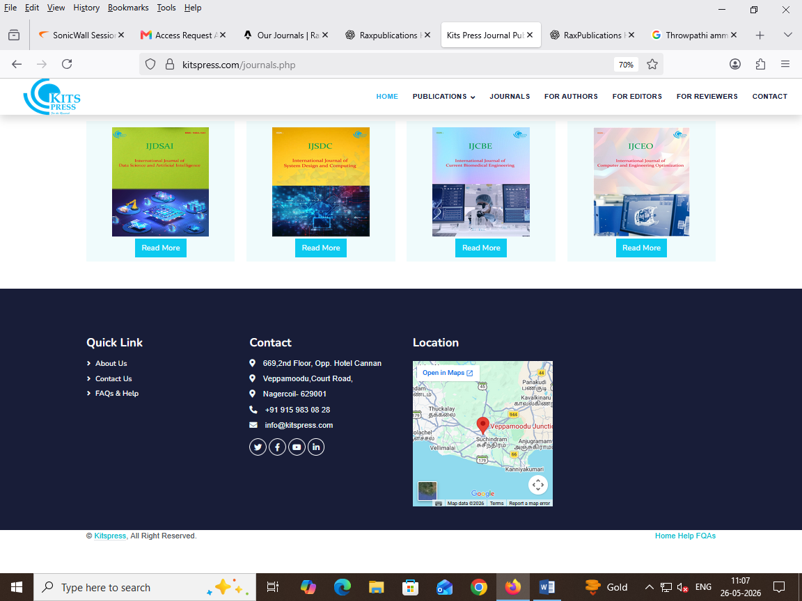
E-ISSN: 2582-XXXX | Bi-Monthly | E-ISSN : | Quarterly — March, June, September, and December.

Page : Archives
Volume 4, Issue 1 (2025) | Volume 1 , Issue 1 (2026)
Published: Jan 15, 2025 | International Journal of Computational Science and Technology | Published: March , 2026 | International Journal of Computational Science and Technology

